Laboratory Manual: IAS Computer

Part I - Introduction

1. What is IAS Computer?
The IAS (Institute for Advanced Study) Computer, designed in 1946 by John von Neumann and his team, is considered one of the earliest stored-program computers. Completed in 1952 at Princeton University, the IAS Computer introduced the architecture that became the foundation of most digital computers: the stored-program concept. In this model, both program instructions and data are stored in the same memory, allowing the computer to be flexible and reprogrammable. Its design influenced modern computing systems and led to the term 'von Neumann architecture'.

2. Registers used in IAS Computer
Activity: Match the registers with their correct definitions.
Memory Buffer Register (MBR)● |  | ●Contains the address of the next instruction.
Memory Address Register (MAR) ● |  | ●Stores the address of the memory location being accessed.
Instruction Register (IR) ● |  | ●Holds operands and results of multiplication/division.
Instruction Buffer Register (IBR) ● |  | ●Holds the opcode of the current instruction.
Program Counter (PC) ● |  | ●Holds a word to be transferred to or from memory.
Accumulator (AC) ● |  | ●Temporarily stores the right-hand instruction.
Multiplier Quotient Register (MQ) ● |  | ●Temporarily stores data/results of arithmetic operations.

3. IAS Computer Instruction Cycle
Activity: Arrange the steps of the IAS Computer Instruction Cycle in the correct order.
__1__ The PC supplies the address of the instruction to MAR.
__2__ The instruction is fetched from memory into the MBR.
__3__ The left-hand instruction is loaded into IR; the right-hand instruction is loaded into IBR.
__4__ The instruction in IR is decoded and executed by the control unit.
__5__ The result of the execution is stored in AC/MQ or memory as required.
__6_ The PC is updated to point to the next instruction.

4. IAS Instruction Set
The IAS Computer used a limited but powerful instruction set that served as the foundation of modern processors. Each instruction was 20 bits long, with an 8-bit operation code (opcode) and a 12-bit memory address. Some key instructions included:
• Load (data from memory to AC)
• Store (data from AC to memory)
• Add/Subtract (between AC and memory contents)
• Multiply/Divide (using AC and MQ registers)
• Transfer control (jumps and conditional branches)
This instruction set provided the essential capabilities needed to perform arithmetic, data transfer, and control operations.

5. Review Questions

1. The IAS Computer was designed at which institution?
- a) Harvard University
- b) Princeton Institute for Advanced Study
- c) MIT
- d) Bell Labs
2. Which register holds the address of the next instruction?
- a) IR
- b) AC
- c) PC
- d) MAR
3. The IAS Computer followed which architecture?
- a) Harvard
- b) Von Neumann
- c) RISC
- d) CISC
4. Word length of IAS Computer?
- a) 16 bits
- b) 32 bits
- c) 40 bits
- d) 64 bits
5. Which instruction stops program execution?
- a) JUMP
- b) STORE
- c) HALT
- d) LOAD

Part II – Programming Using IAS Simulator

1. IAS Overview & Programming Model
The IAS (Institute for Advanced Study) computer is a classic stored‑program machine with a 40‑bit word. Each word can hold either a 40‑bit data value or two 20‑bit instructions (LEFT: bits 0–19, RIGHT: bits 20–39). A 20‑bit instruction has an 8‑bit opcode and a 12‑bit address. The programming model is accumulator‑based with key registers: PC, AC, MQ, MAR, MBR, IR, and IBR. Programs execute left‑to‑right within a word, then proceed to the next word unless branched.

2. Using the Web IAS Simulator (Unicamp)
Open the Web IAS Simulator in a modern browser. The interface exposes controls like ‘Load Mem. Map into IAS Memory’, ‘Load Map from File’, ‘Reset’, ‘Zero Reg/Mem’, ‘Next’, ‘Step’, ‘Run All’, and a timing field ‘ms/cycle’. Registers shown include PC, AC, MQ, MBR, IR, IBR, and MAR. The MAIN MEMORY panel visualizes addresses and instruction halves.
Recommended workflow:
- Reset → Zero Reg/Mem to clear state.
- Paste your program (or memory map) and use “Load Mem. Map into IAS Memory”. If available, you can load from a .txt file with “Load Map from File”.
- Click Step to execute one micro‑step; Next to advance to the next instruction half; Run All to execute until HALT.
- Observe register updates (PC/IR/IBR/AC/MQ) after each step to understand control flow and data movement.
Two instructions share one memory word. Branch targets must specify whether you jump to the LEFT (0:19) or RIGHT (20:39) half of the target word.

3. Accepted Mnemonics & Syntax (Web IAS)
The Web IAS Simulator accepts common mnemonics (case‑insensitive in many examples). Typical instruction set includes:
LD / LOAD M(X) AC ← M[X]
LD- / LOAD -M(X) AC ← −M[X]
LD| / LOAD |M(X)| AC ← |M[X]|
ST / STOR M(X) M[X] ← AC
ADD M(X) AC ← AC + M[X]
ADD| M(X) AC ← AC + |M[X]|
SUB M(X) AC ← AC − M[X]
SUB| M(X) AC ← AC − |M[X]|
LDmq AC ← MQ
LDmq_mx / LDMQ M(X) MQ ← M[X]
MUL M(X) (AC,MQ) ← MQ × M[X] (stored high in AC, low in MQ)
DIV M(X) AC ← ⌊(AC:MQ)/M[X]⌋ ; MQ ← (AC:MQ) mod M[X]
LSH / RSH Shift AC left/right
JMP M(X,0:19) Jump to LEFT half of word X
JMP M(X,20:39) Jump to RIGHT half of word X
JMP+ M(X,0:19)/(20:39) Conditional jump if AC ≥ 0
HALT Stop execution
Labels generally refer to LEFT halves unless explicitly suffixed or mapped. When in doubt, use explicit forms like JMP M(5,20:39).

4. Lab 1 – Load/Store/Add on the Web Simulator
Objective: Add two values and store the result; observe AC/MBR/IR/IBR transitions.
/ Program: SUM = A + B (Web IAS)
/ Code @ 000, Data @ 100+
000(0:19): LOAD M(100)
000(20:39): ADD M(101)
001(0:19): ST M(102)
001(20:39): HALT
/ Data:
100: 23
101: 11
102: 0
Steps on the Web Simulator:
- Reset → Zero Reg/Mem.
- Paste the memory map and click “Load Mem. Map into IAS Memory”.
- Click Next and make a screenshot of each step until the program stops and verify M[102] becomes 34.

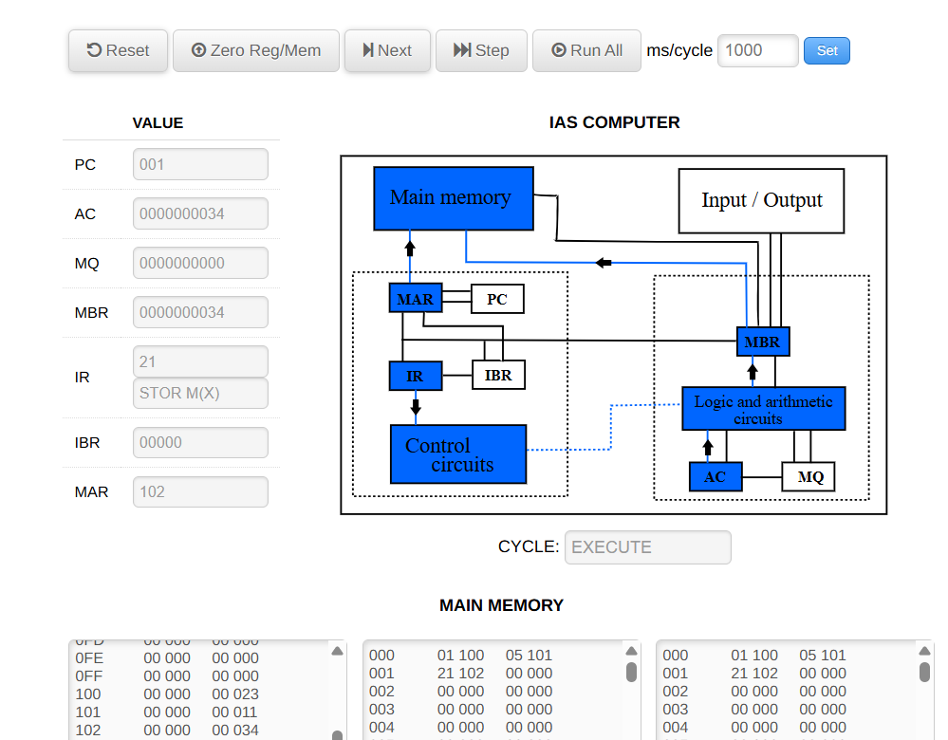
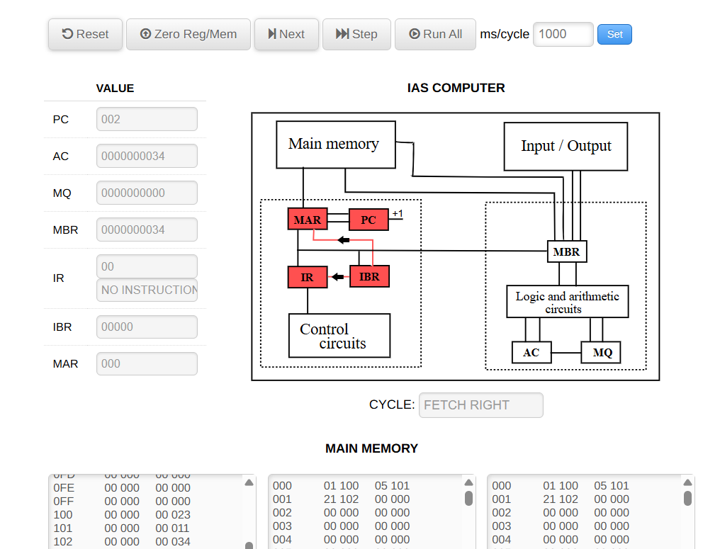
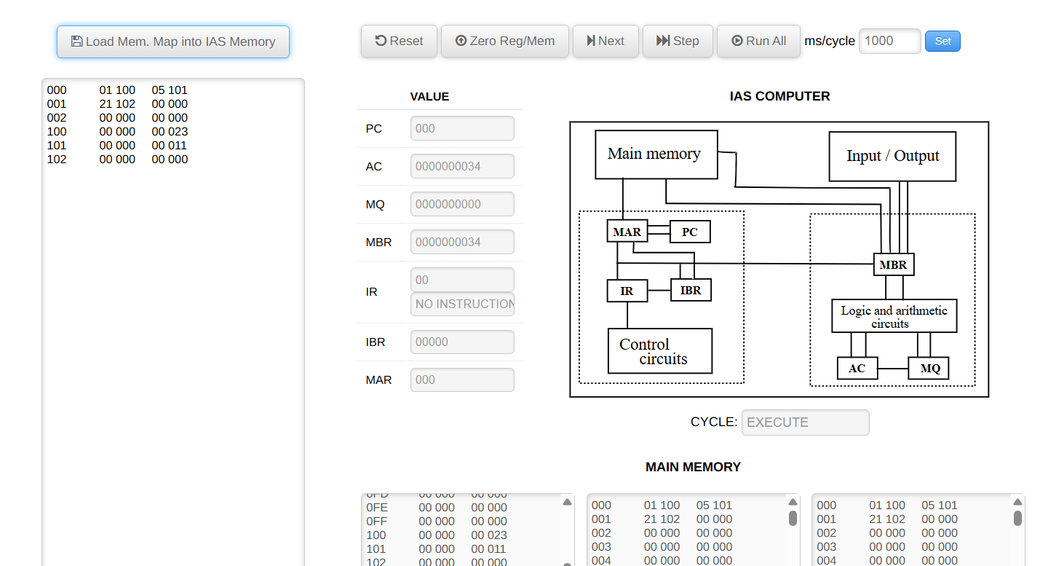
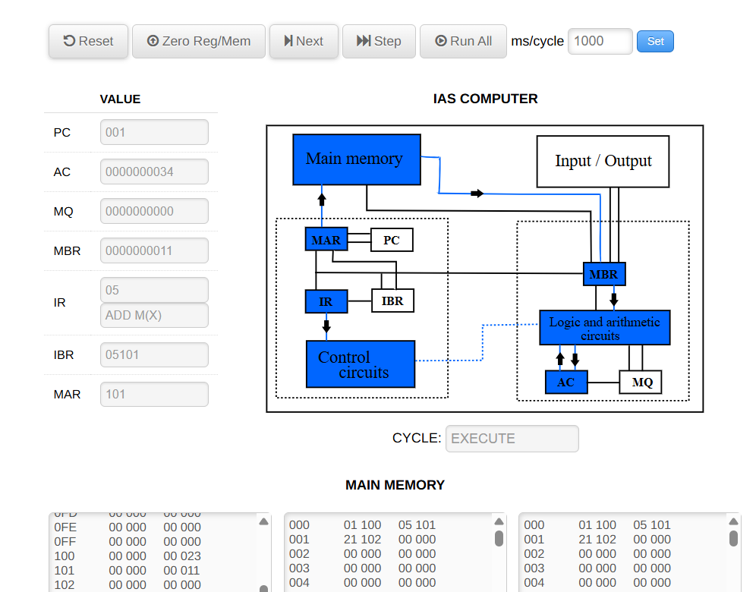
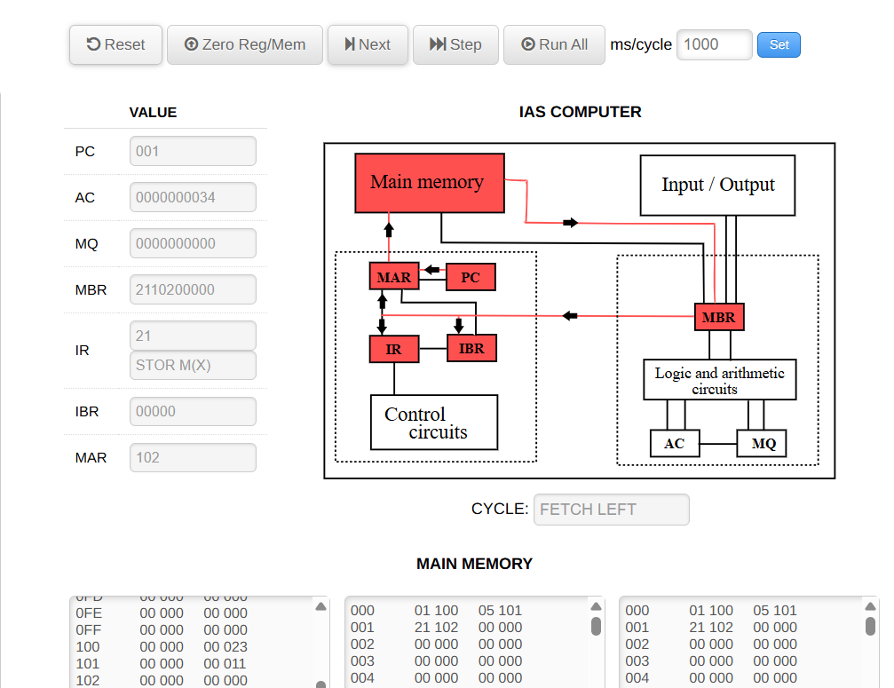
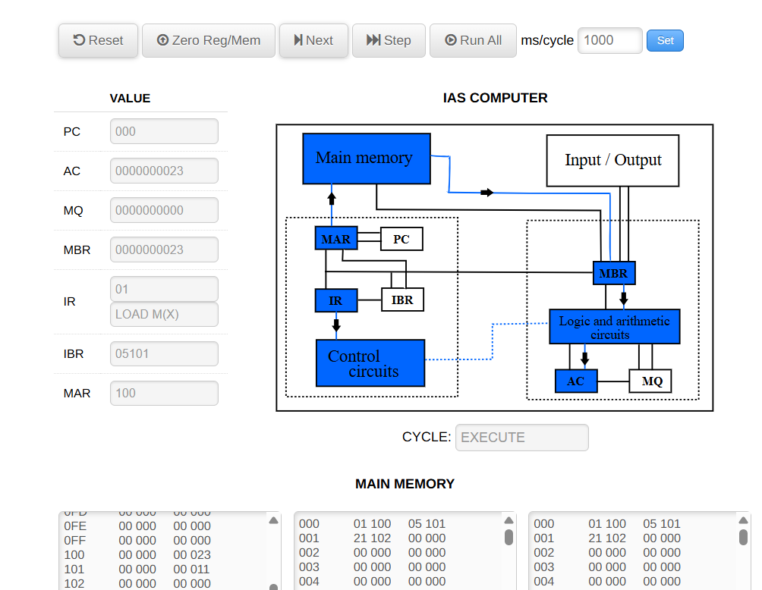
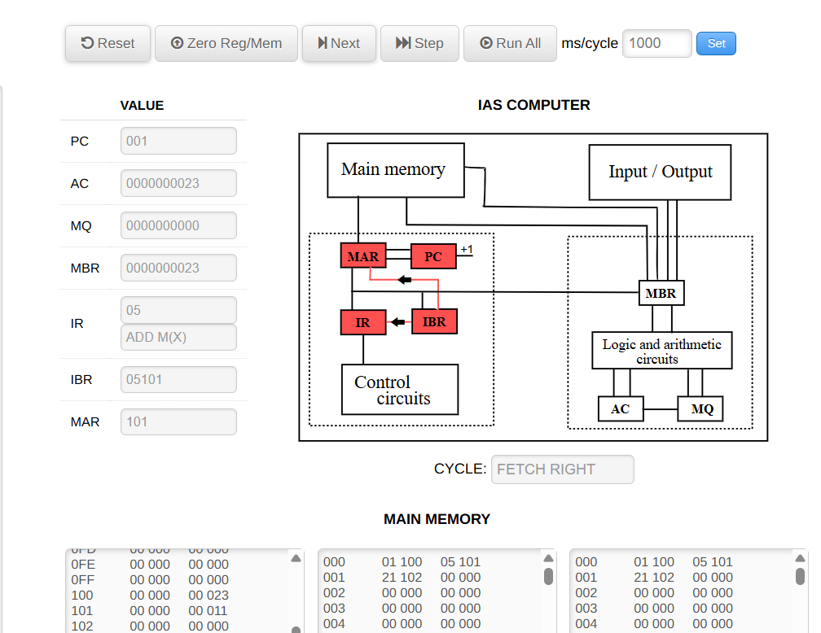
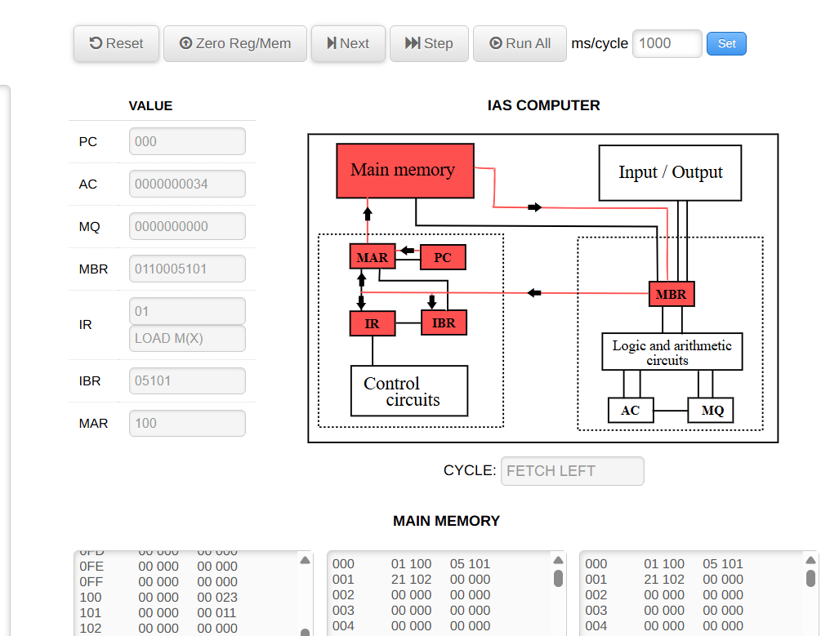

5. Lab 2 – Branching with JUMP and JUMP+
Objective: Use conditional branching to compute |X| into Y.
/ ABS(X) -> Y; X @120, Y @121
000(0:19): LOAD M(120)
000(20:39): JMP+ M(002,0:19) / If AC ≥ 0, skip negate
001(0:19): LOAD -M(120)
001(20:39): ST M(121)
002(0:19): ST M(121)
002(20:39): HALT

/ Data:
120: -15 / try also 42
121: 0
Follow‑ups:
- Modify to compute max(X,Y).
- Demonstrate a branch to the RIGHT half using JMP M(addr,20:39) and explain PC/IBR effects.

For -15 application
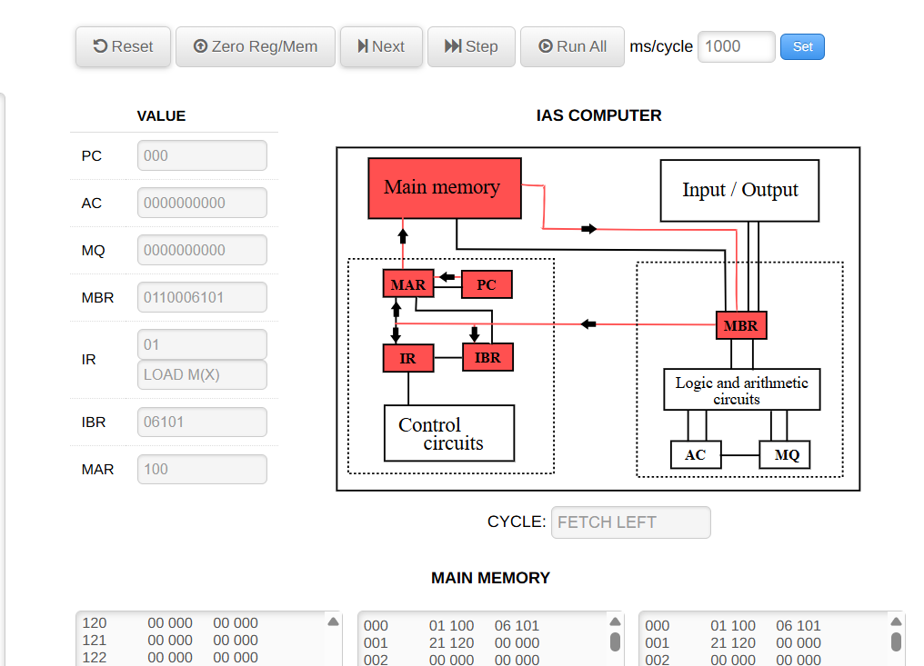
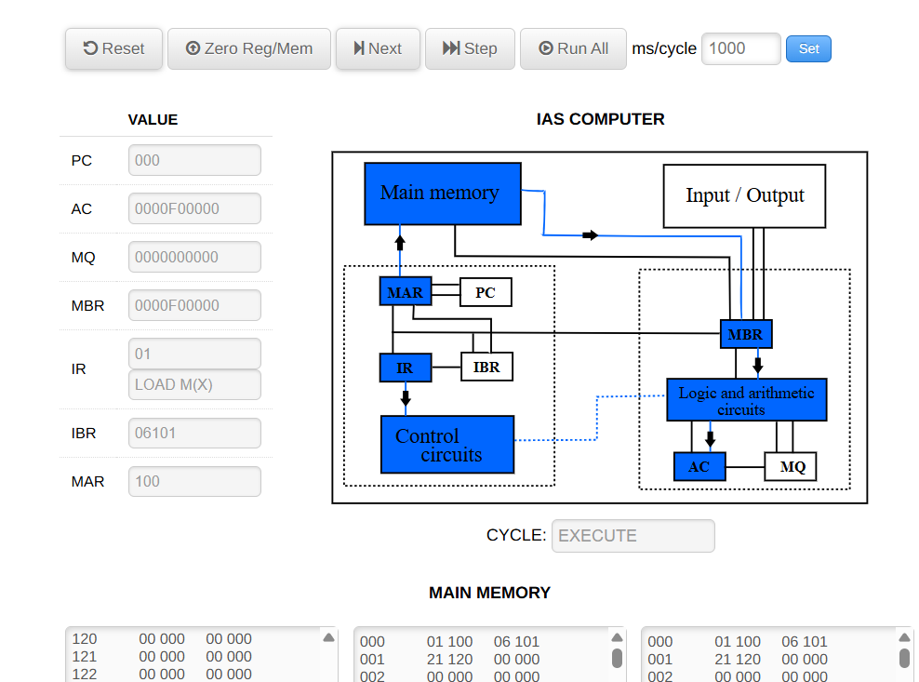
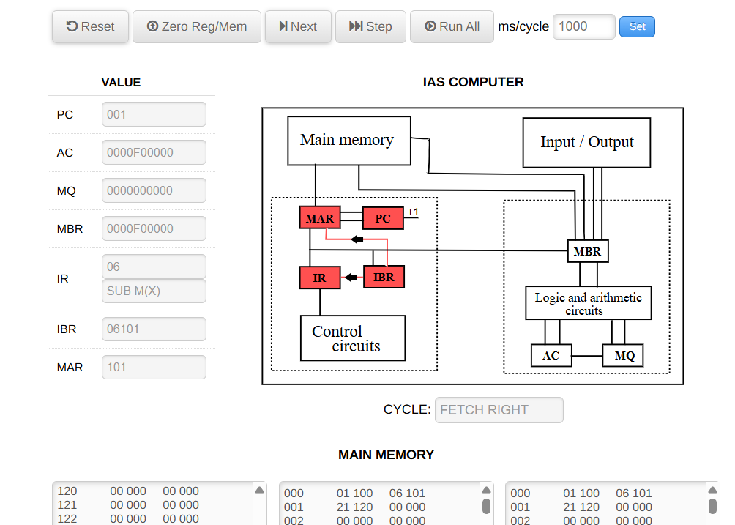
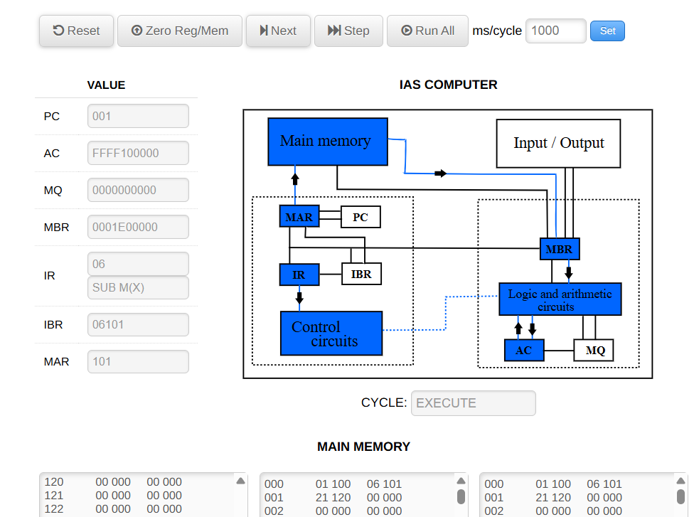

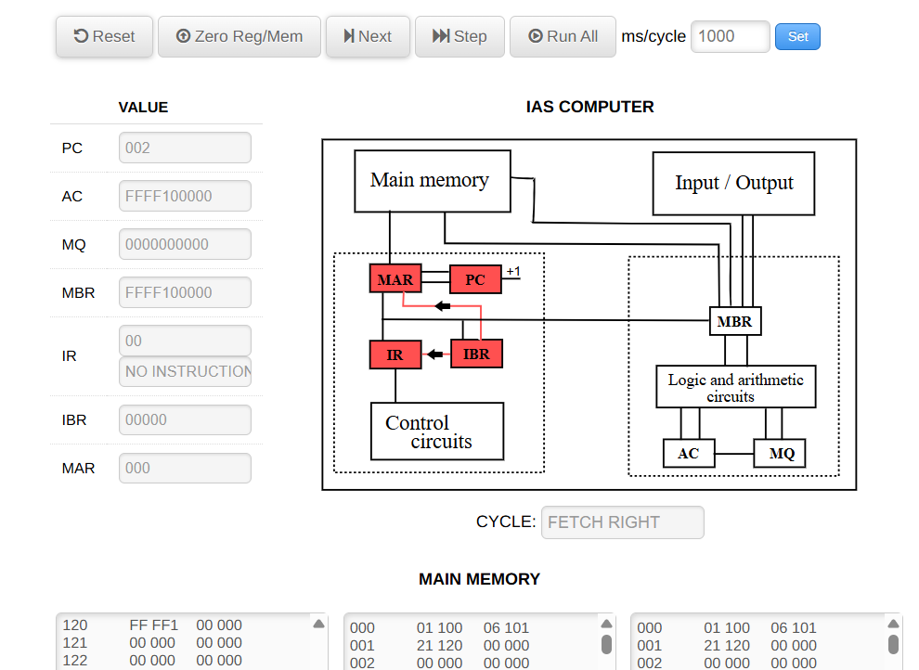
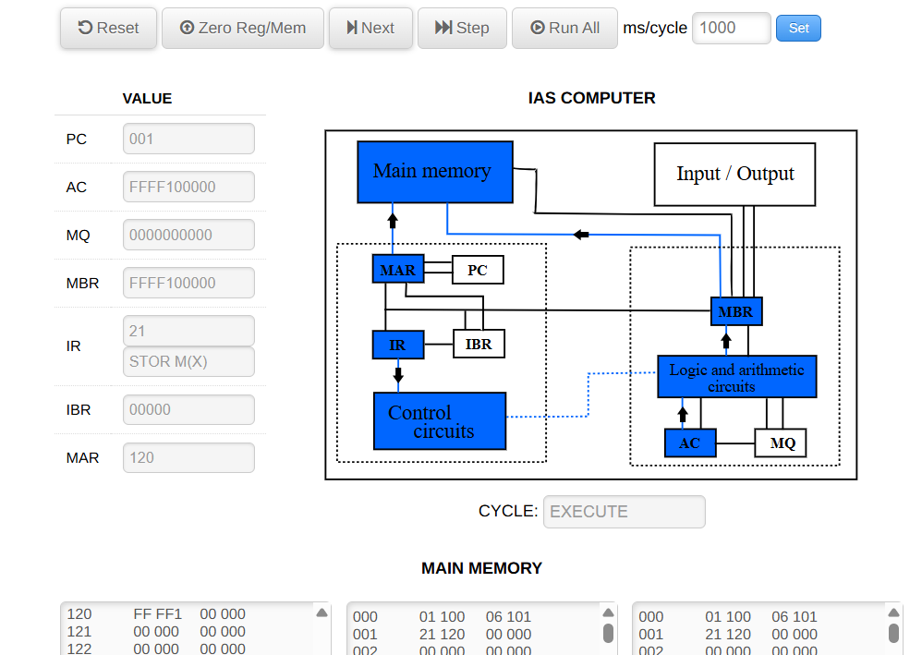
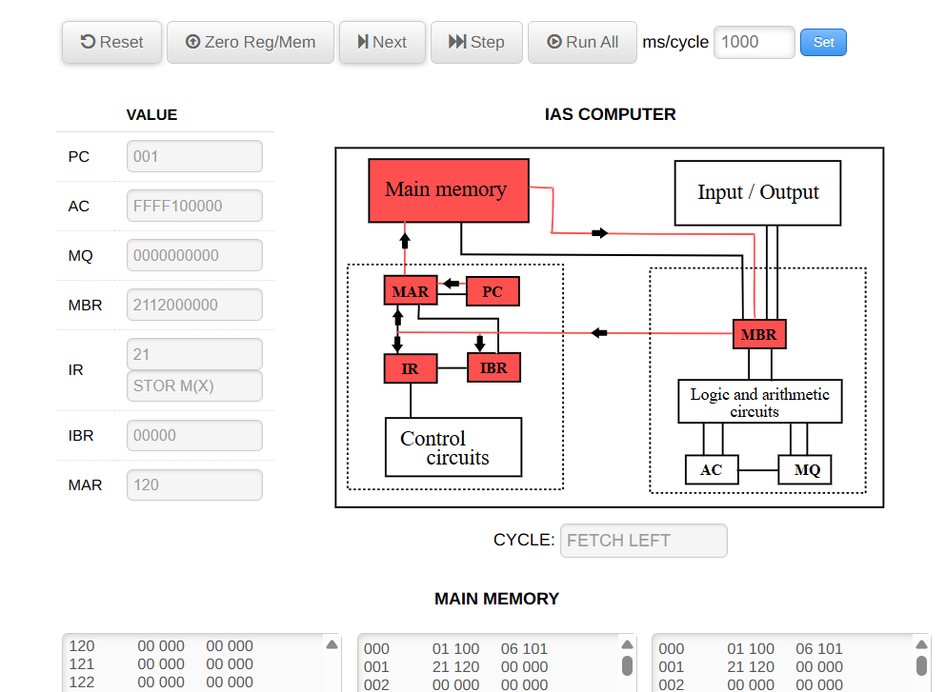

For 42 application
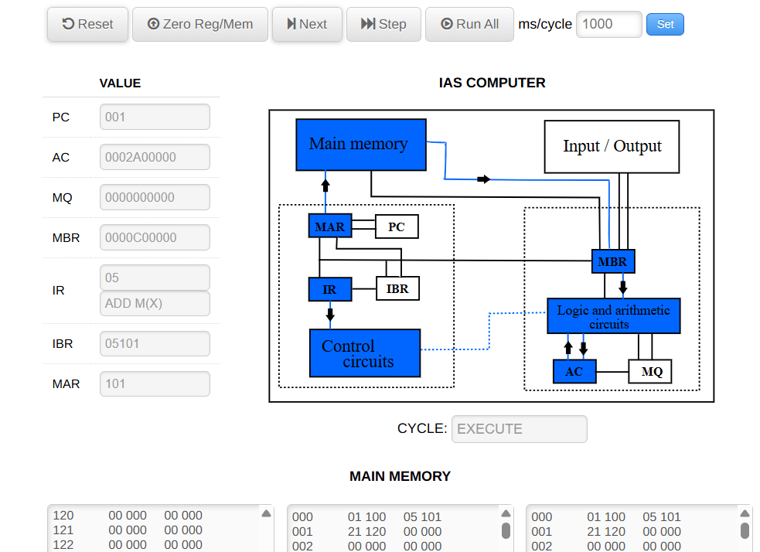
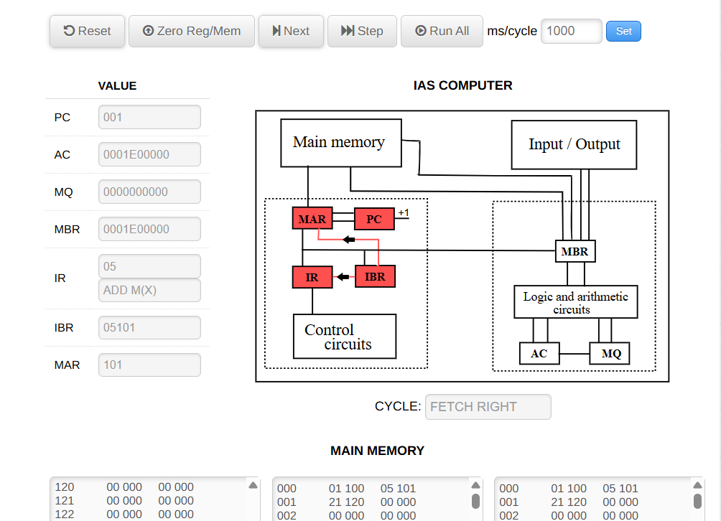
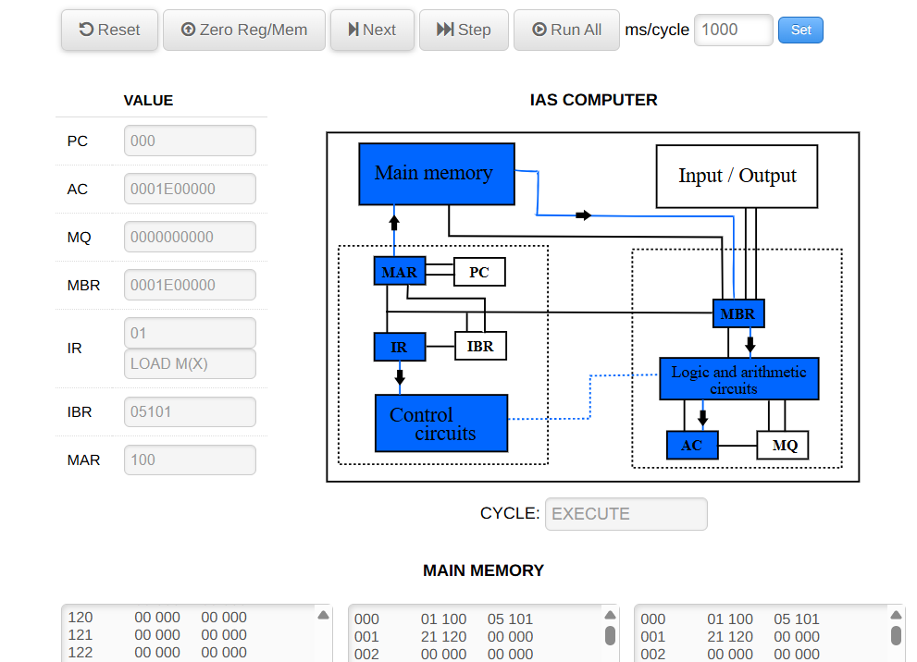
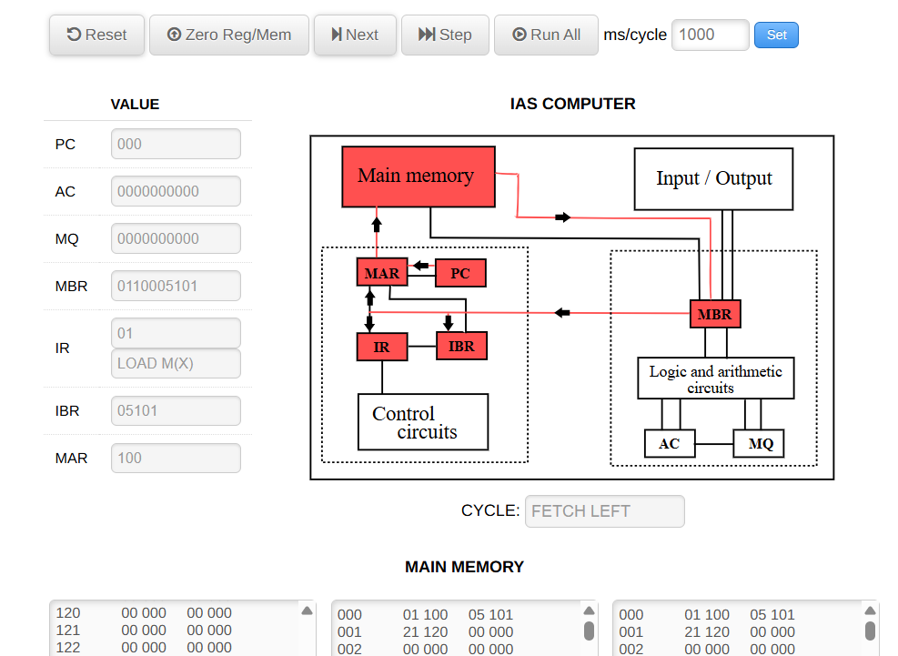
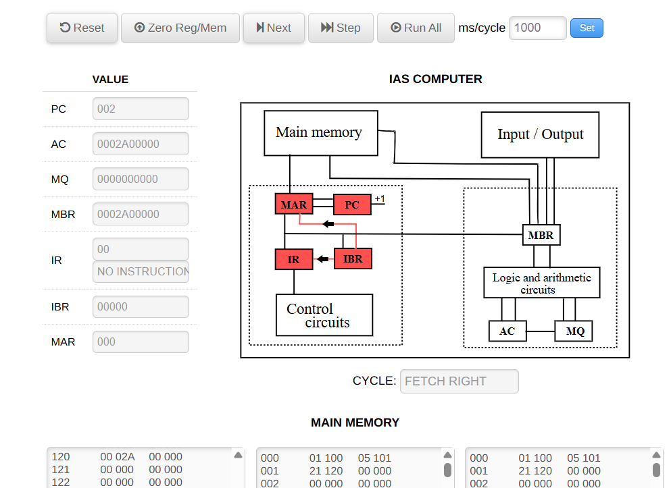
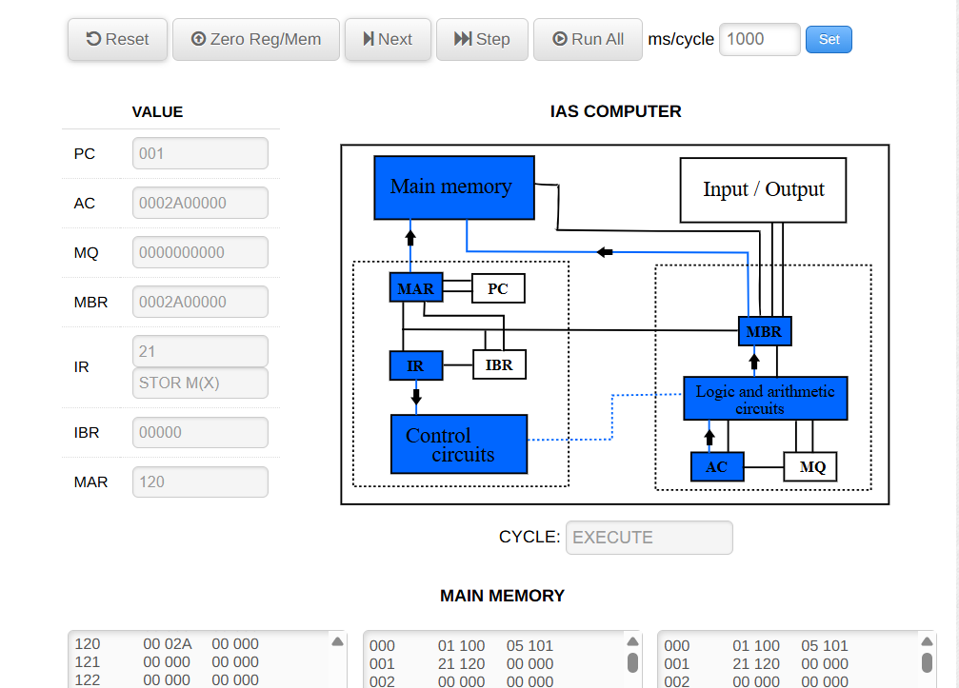
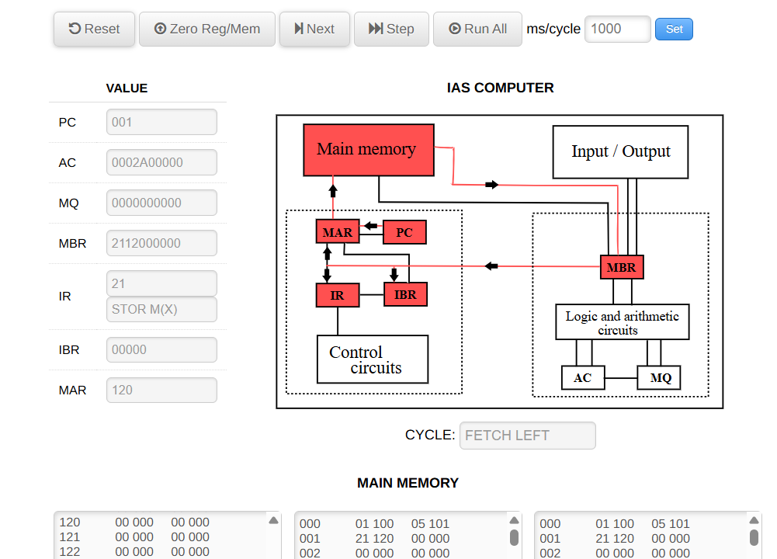

6. Lab 3 – Loops & Arrays on the Web Simulator
Objective: Sum N numbers at 200..(200+N−1) into SUM (199).
/ SUM N elements; N @198; SUM @199
000(0:19): LOAD M(198) / N
000(20:39): ST M(210) / COUNT=N
001(0:19): LOAD M(199) / ACCUM=0
001(20:39): ST M(211)
002(0:19): LOAD M(210) / COUNT
002(20:39): JMP+ M(004,0:19) / if COUNT ≥ 0 continue
003(0:19): JMP M(008,0:19) / else done
003(20:39): NOP / (if supported; else leave blank/comment)
004(0:19): LOAD M(211) / ACCUM
004(20:39): ADD M(200) / + *current*
005(0:19): ST M(211) / save
005(20:39): LOAD M(210) / COUNT
006(0:19): SUB M(212) / −1
006(20:39): ST M(210)
007(0:19): LOAD M(213) / ptr
007(20:39): ADD M(212) / +1
008(0:19): ST M(213) / ptr←ptr+1
008(20:39): JMP M(002,0:19) / loop
009(0:19): LOAD M(211)
009(20:39): ST M(199)
010(0:19): HALT

/ Data:
198: 3
199: 0
200: 5
201: 7
202: 9
210: 0 / COUN
211: 0 / ACCUM
212: 1 / ONE
213: 200 / pointer

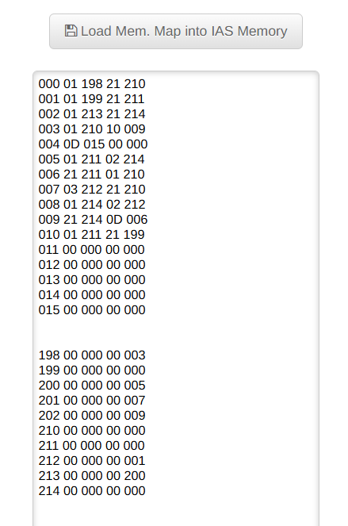

7. Lab 4 – MQ with MUL/DIV; LSH/RSH
Objective: Practice (AC,MQ) product placement and division semantics used by the Web IAS Simulator.
/ Multiply A×B; store hi/lo
000(0:19): LDmq_mx M(301) / MQ ← B
000(20:39): MUL M(300) / (AC,MQ) ← MQ × M[300]
001(0:19): ST M(302) / product_hi ← AC
001(20:39): LDmq / AC ← MQ (low)
002(0:19): ST M(303) / product_lo ← AC
002(20:39): HALT

/ Data:
300: 13
301: 17
302: 0
303: 0
Follow‑up: Use DIV M(X) after loading AC:MQ as a 80‑bit dividend; store quotient and remainder; then demonstrate LSH/RSH.
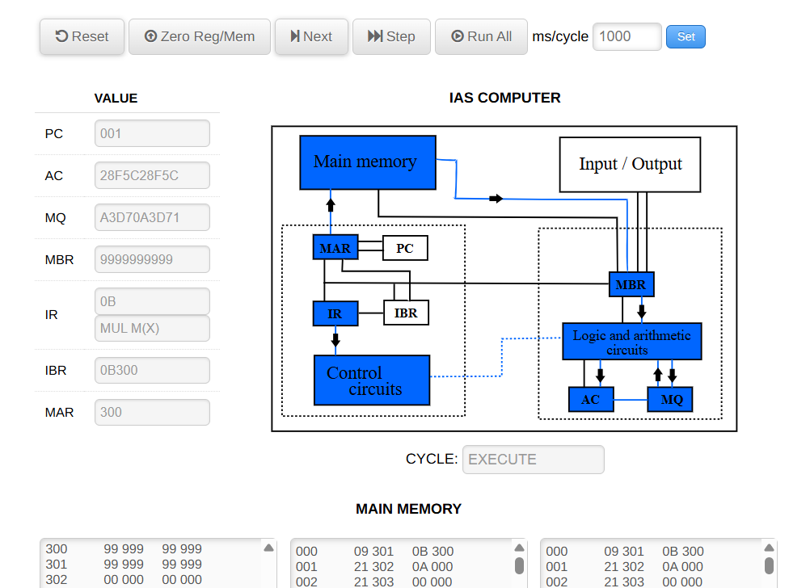
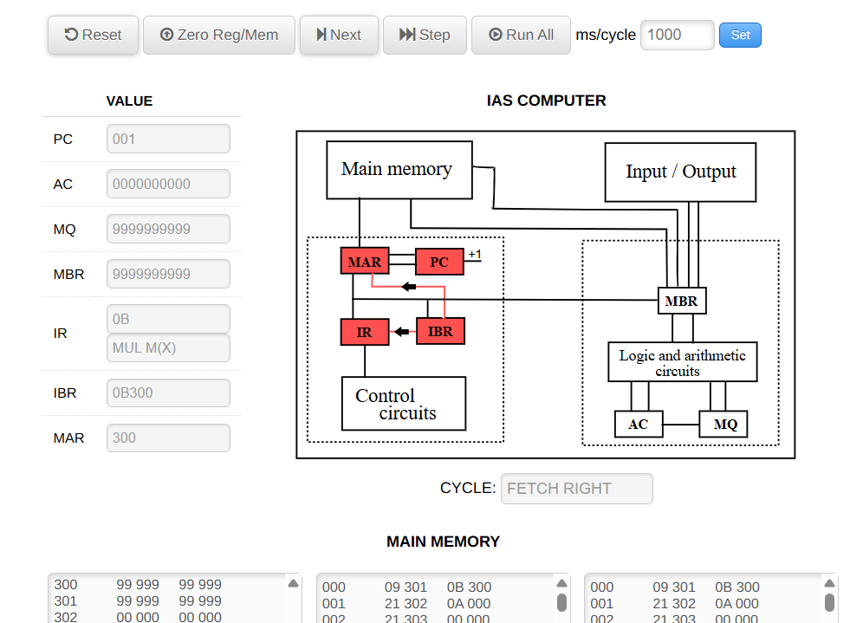
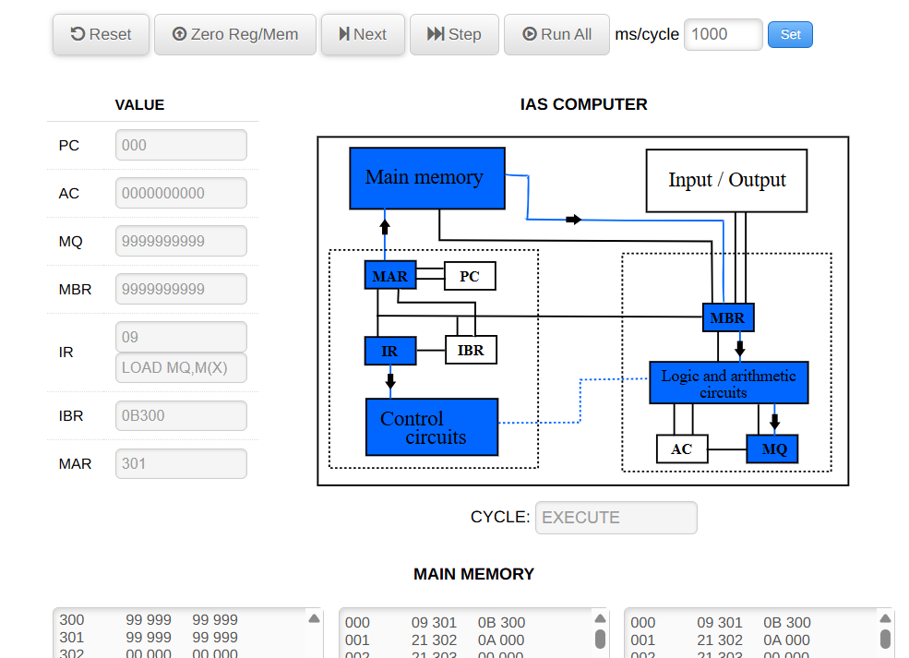
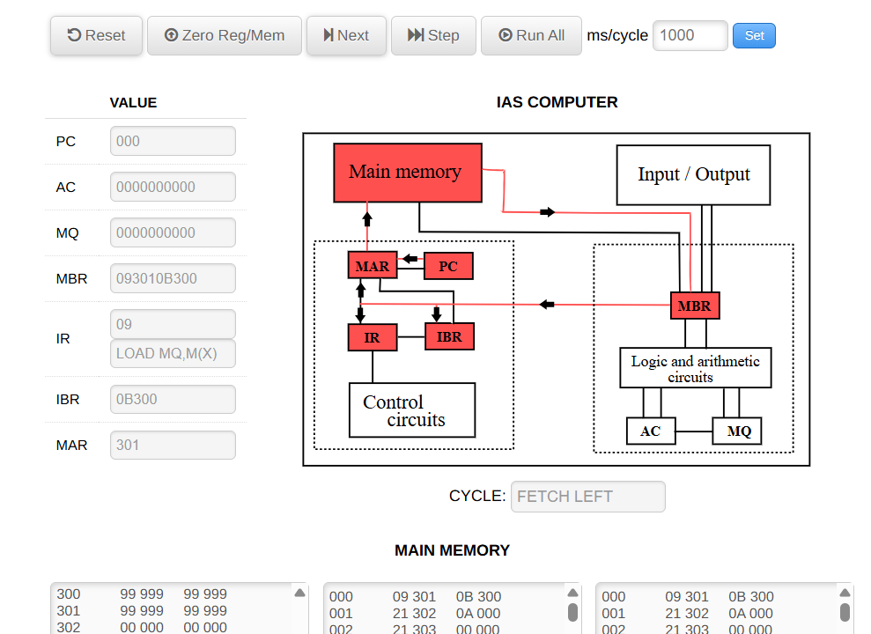
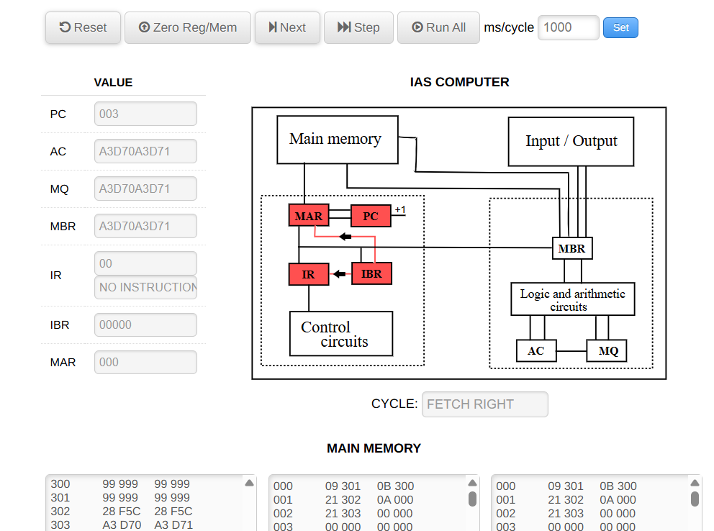
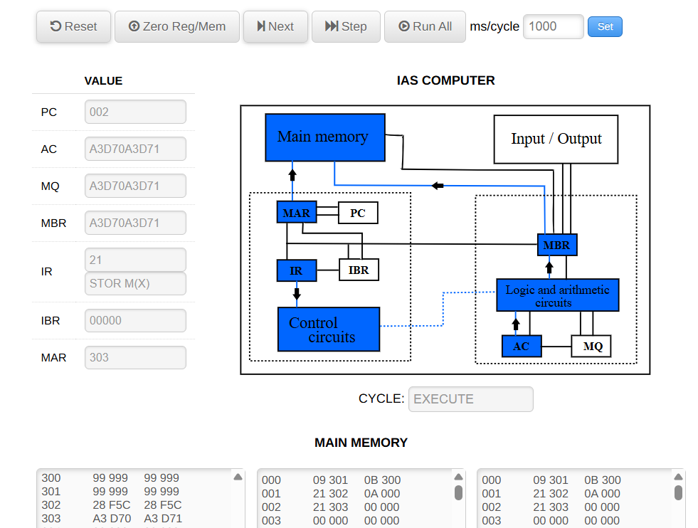
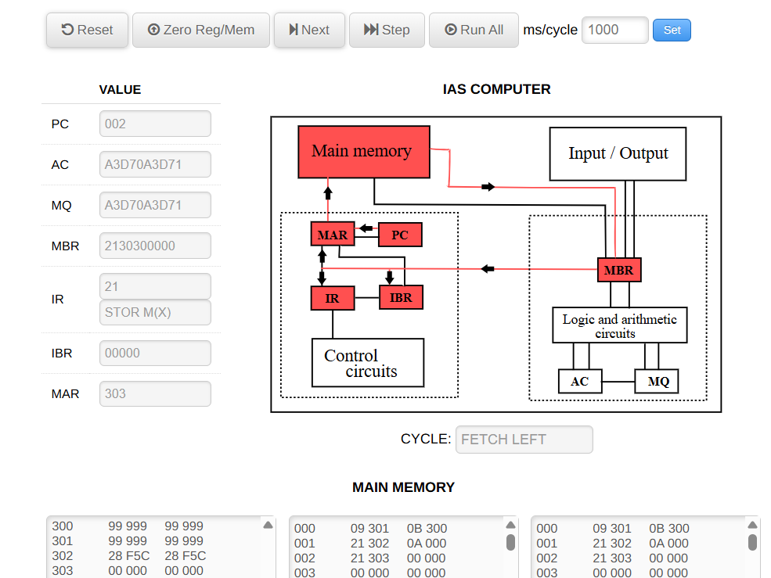
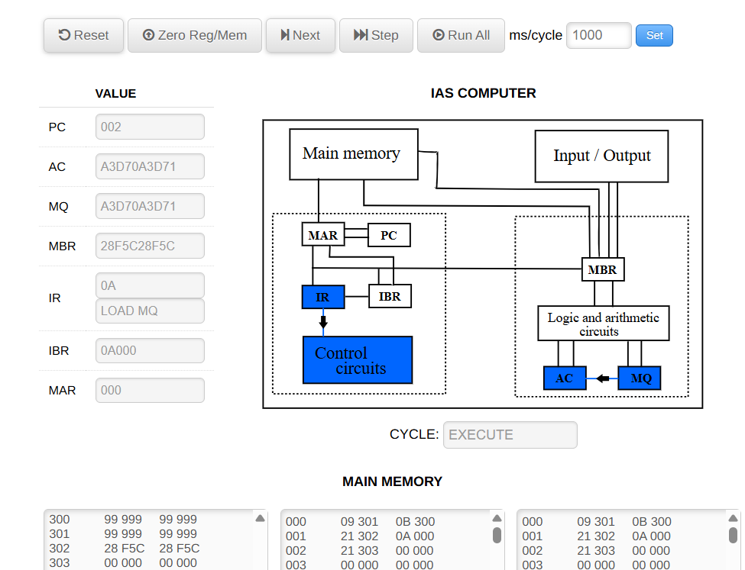
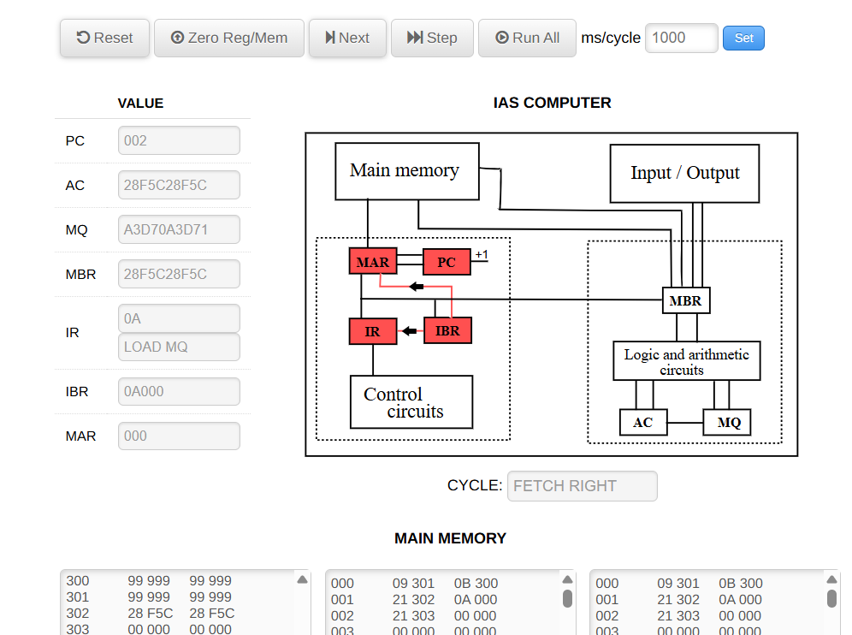
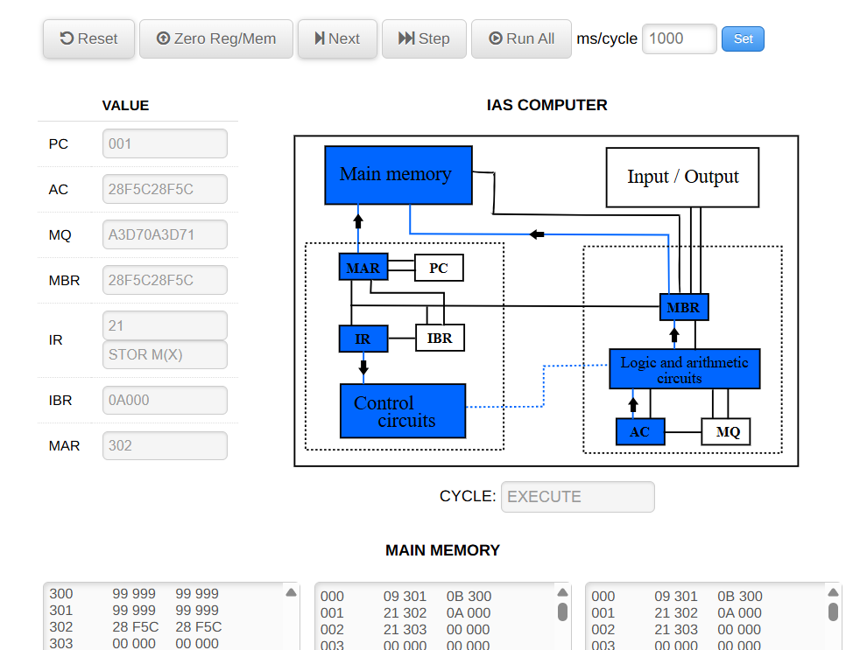
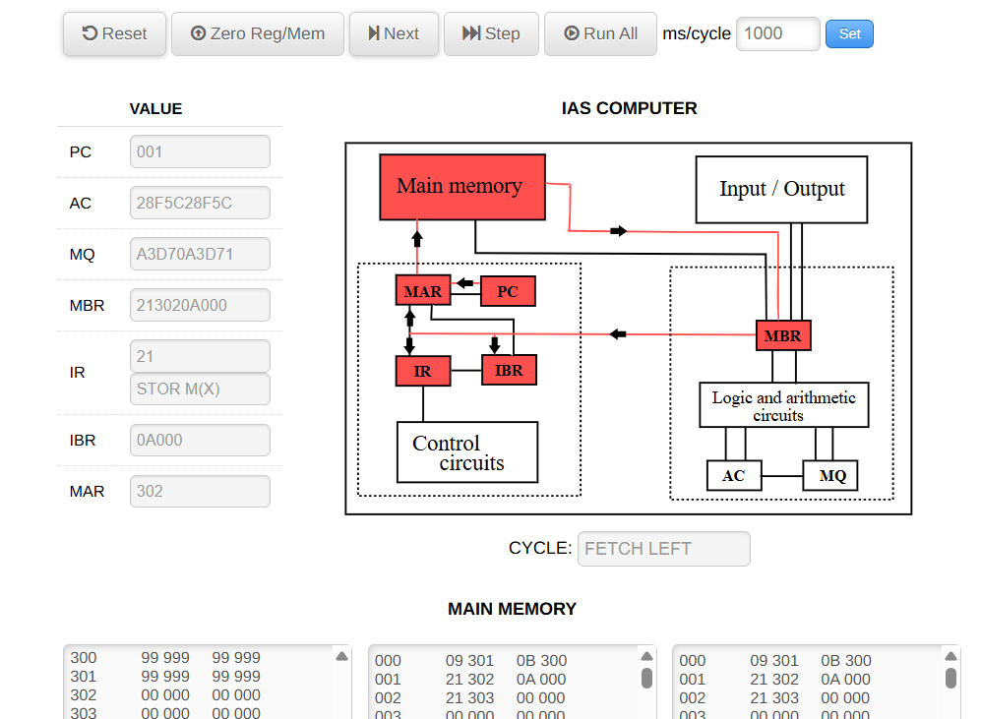

Appendix A – Quick Reference
Registers: PC, AC, MQ, MAR, MBR, IR, IBR.
Instruction halves: LEFT (0:19), RIGHT (20:39). Use explicit branch forms to target halves.
Execution order: Left → Right within a word; then next word.

Appendix B – Web IAS Tips, Errors, and Troubleshooting
• Labels are typically allowed on LEFT‑half instructions. If you place a label on a RIGHT half, the loader may reject it with an error like “Labels can only be used with instructions in the left half of a word.” Move the label to the LEFT or use explicit jump forms.
• If your program appears to skip the RIGHT half after a branch, remember that jumps can land on either half of the target, and the fetch logic uses IBR to hold the other half.
• Initialize data and state: use Zero Reg/Mem before loading your map to prevent stale values.
• If MUL/DIV behavior seems off, verify the simulator’s convention: product high bits in AC, low in MQ; DIV places quotient in AC and remainder in MQ.

